**Project 3 Report**

**Figure 1:**

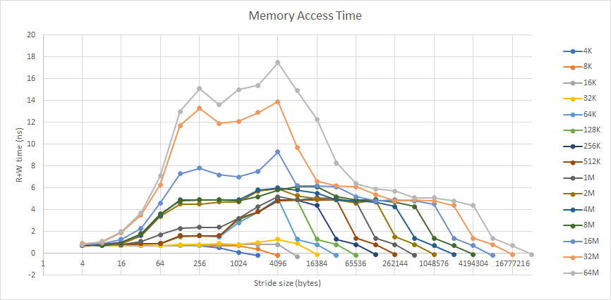

Cache Performance of Personal Machine

**Figure 2:**

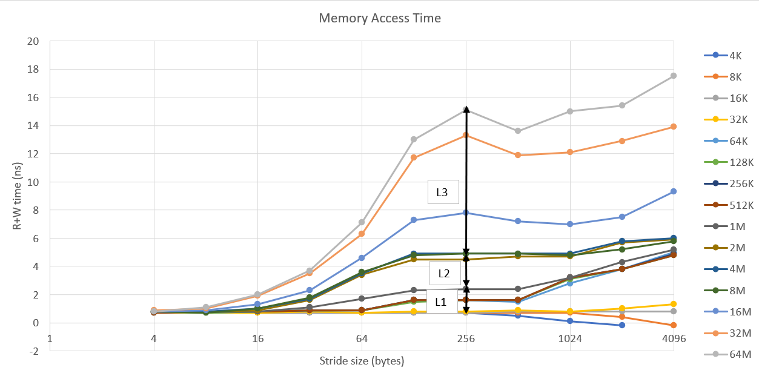

Focused Cache Performance of Personal Machine with Cache Hits Highlighted

**Manufacturer & Model of CPU:** Intel Xeon W-2255 CPU @ 3.70 GHz

**Machine:** cirrus4

**OS:** Ubuntu

**Physical Memory:** 16 GB DRAM

|  | **L1** | **L2** | **L3** | **Main Memory** |
| --- | --- | --- | --- | --- |
| **Size (Bytes)** | 32768 = 32 KB | 1048576 = 1 MB | 20185088 = 2 MB | 65.54 GB |
| **access time (ns)** | 0.8 | 2.4 | 4.9 | **X** |

Miss Penalty = upper_bound(cache_access_time) - lower_bound(cache_access_time)

L1: 2.4 - 0.7 = 1.7 ns

L2: 4.5 - 2.4 = 2.1 ns

L3: 15.1 - 4.5 = 10.6 ns

TLB: 17.5 - 15.1 = 2.4 ns

|  | **L1** | **L2** | **L3** | **TLB** |
| --- | --- | --- | --- | --- |
| **Miss penalty (ns)** | 1.7 | 2.1 | 10.6 | 2.4 |

**Screenshots:**

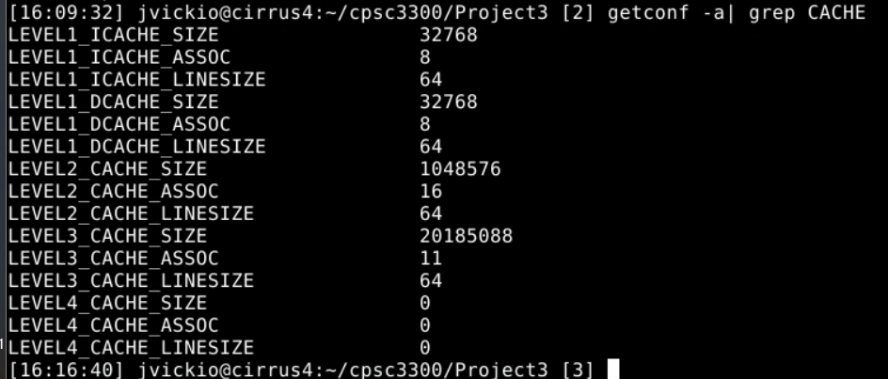

Cache Information

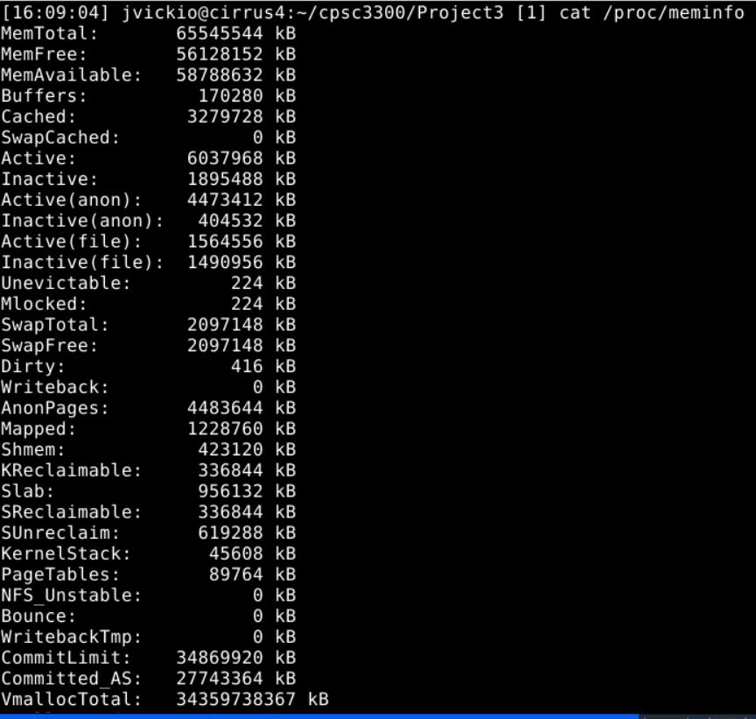

Memory Information